SIMATS ENGINEERING
ASSESSMENT TOOL 2 - Medium(Assignment 1)
COURSE CODE: CSA09 COURSE NAME: Programming in Java COURSE OUTCOME COVERED
CO2: Implement Collection Framework interfaces such as List, ArrayList, Set, Map, HashTable, and HashMap using iterators and generics to store, retrieve, and process groups of objects in web applications.(BL3,BL4)
Assessment Tool Weightage: 10%
QUESTIONS: 40 (each student assigned distinct questions) Total Marks: 100
ANNEXURE A
Assignment 1
Code of Conduct:
I _________A.Janvi Chowdary(192525455)___________ (Name / Reg No) certify that this submission is my original work and that I have adhered to the guidelines specified for this assessment.
I understand that any violation of academic integrity rules will result in disciplinary action.
Signature of the student:
RUBRICS FOR CALCULATION:
Criteria | Level 4 (Exemplary) | Level 3 (Proficient) | Level 2 (Developing) | Level 1 (Beginning)
Problem Understanding
Algorithm
Code Implementation
Competitive Performance
Test Case Handling

Annexure A

Assignment 1

Question 40 – Digital Certificate Verification System

Problem Statement:
A university stores and verifies students' digital certificates.

Questions
- Develop a Java program using HashMap to manage certificate records.

Code:
import java.util.HashMap;

public class Main {

public static void main(String[] args) {

HashMap<String, String> certificates = new HashMap<>();

// Add certificate records
certificates.put("CERT101", "Rahul - B.Tech CSE");
certificates.put("CERT102", "Priya - B.Tech AI");
certificates.put("CERT103", "Arun - B.Tech IT");

// Display all records
for (String id : certificates.keySet()) {
System.out.println("Certificate ID : " + id);
System.out.println("Student Details : " + certificates.get(id));
System.out.println();
}
}
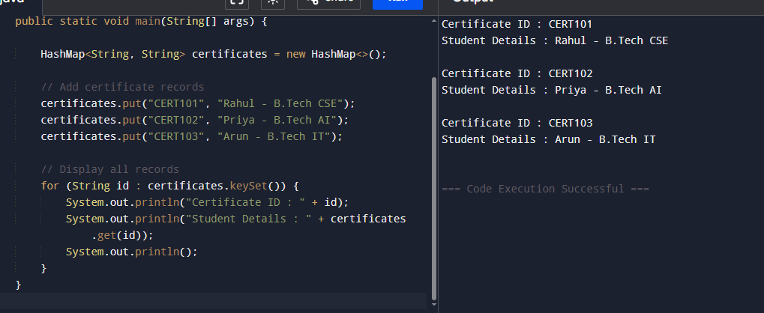
}

- Modify the program to verify certificate details using a unique certificate ID.

Code:

import java.util.HashMap;
import java.util.Scanner;

public class Main {
public static void main(String[] args) {

// Create HashMap
HashMap<String, String> certificates = new HashMap<>();

// Add certificate records
certificates.put("CERT101", "Rahul - B.Tech CSE");
certificates.put("CERT102", "Priya - B.Tech AI");
certificates.put("CERT103", "Arun - B.Tech IT");

// Read Certificate ID
Scanner sc = new Scanner(System.in);
System.out.print("Enter Certificate ID: ");
String id = sc.nextLine();

// Verify Certificate
if (certificates.containsKey(id)) {
System.out.println("Certificate Verified");
System.out.println("Student Details: " + certificates.get(id));
} else {
System.out.println("Certificate Not Found");
}

sc.close();
}
}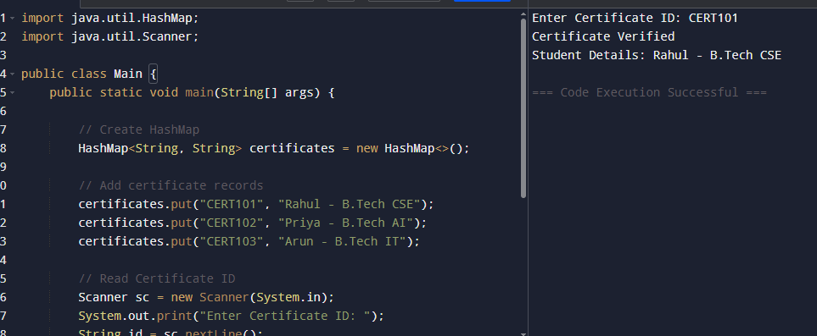

- Compare HashMap and TreeMap for certificate management.

HashMap | TreeMap
Stores records in random order. | Stores records in sorted order (ascending by key).
Faster retrieval and insertion (O(1) average). | Slower retrieval and insertion (O(log n)).
Allows one null key. | Does not allow null keys.
Best for fast certificate verification using Certificate ID. | Best when certificate records need to be displayed in sorted order.
Uses Hash Table internally. | Uses Red-Black Tree internally.

- Discuss the role of Java Collections Framework in secure digital document management.

- Provides efficient data structures such as HashMap, TreeMap, and ArrayList to store digital certificates.
- Enables fast searching and retrieval of certificate records using unique certificate IDs.
- Helps organize and manage large numbers of digital documents efficiently.
- Supports easy insertion, updating, and deletion of certificate records.
- Improves application performance and scalability.
- Makes the code reusable, maintainable, and easier to develop.

